Appendix B
Photos
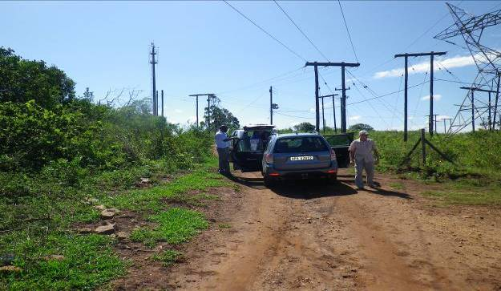
Fig 1 Start of the proposed powerline corridor outside Impala substation south of the preferred corridor

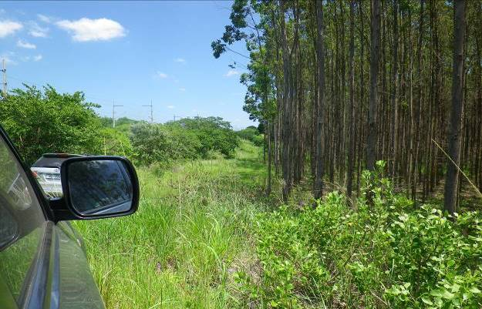
Fig 2 Start of the proposed powerline corridor outside Impala substation south of the preferred corridor

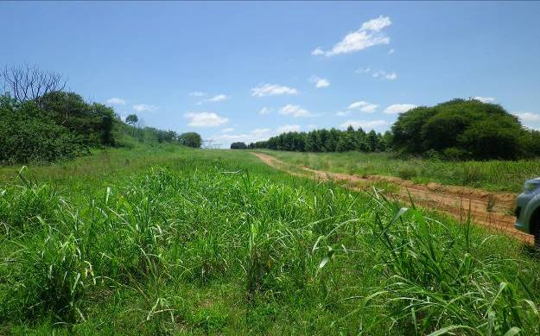
Fig 3 Area south-east of the preferred corridor

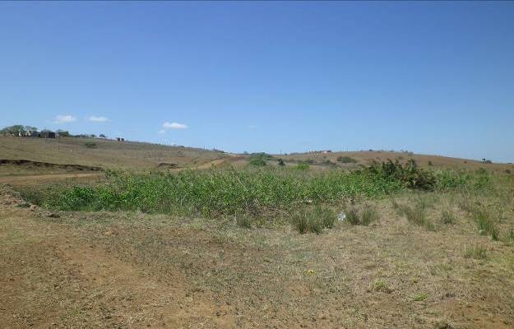
Fig 4 Middle of the preferred powerline corridor

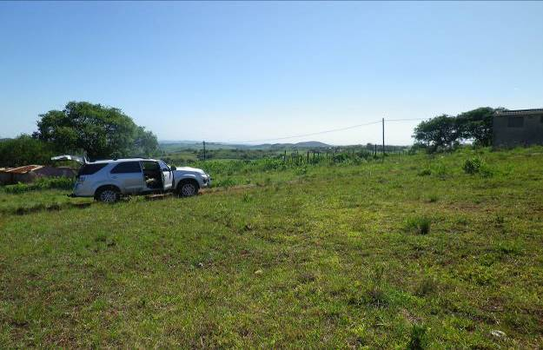
Fig 5 Area east of the middle of the preferred corridor

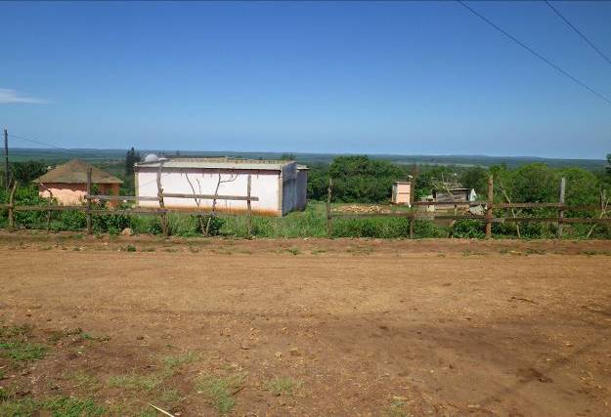
Fig 6 Area west of the middle of the preferred corridor

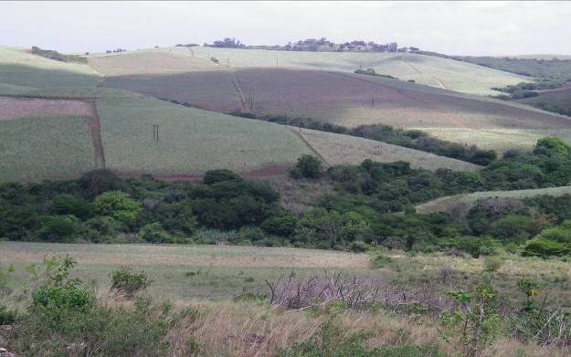
Fig 7 Area middle of preferred corridor, above Nseleni River

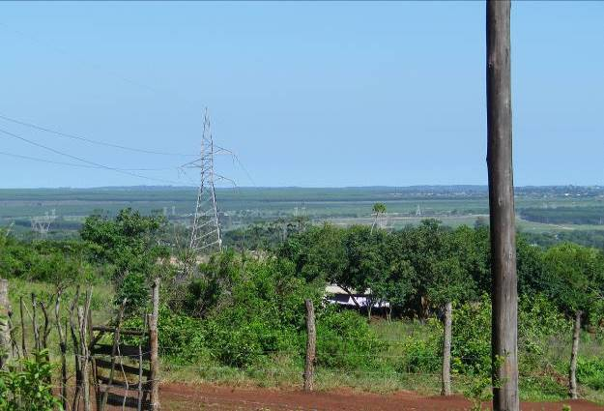
Fig 8 Area North of preferred corridor, above Nseleni River along rural area

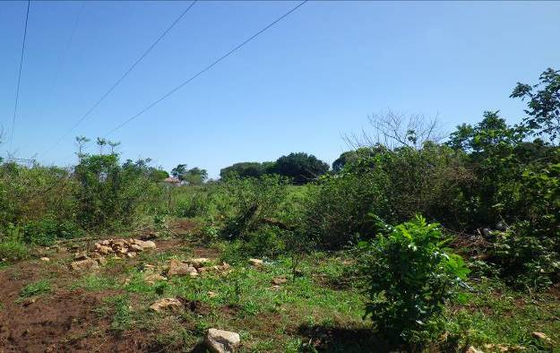
Fig 9 Area North of preferred corridor, above Nseleni River along rural area

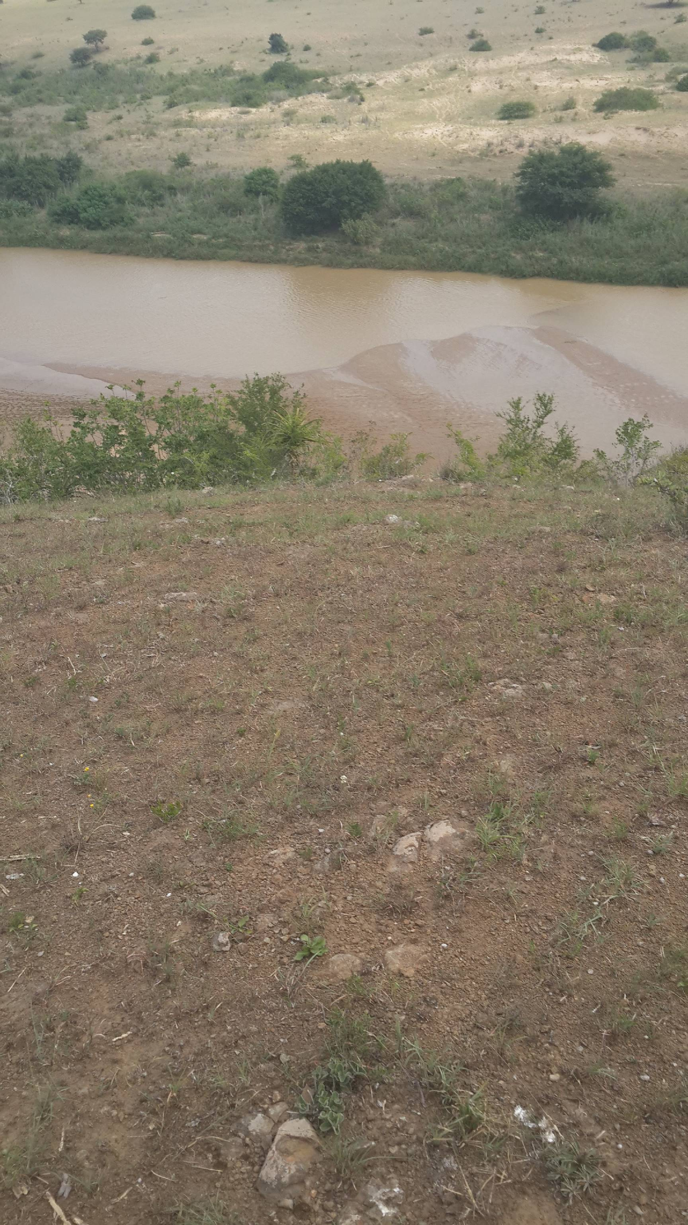
Fig 10 Area North of preferred corridor, across Umfolozi River

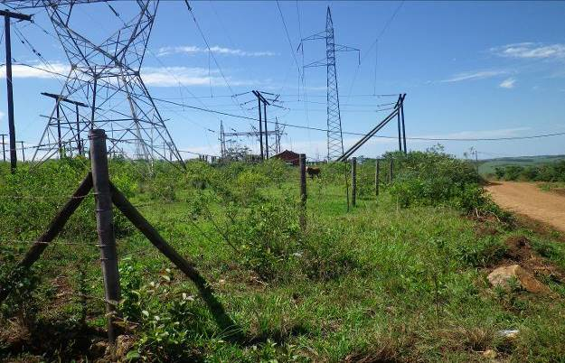
Fig 11 Area North of preferred corridor, at Mtubatuba substation

